TREKKING MANAGEMENT SYSTEM REPORT

1.Student Details
Name: Mrigaank Sharma
Roll Number: 23F2003457
Email: 23f2003457@ds.study.iitm.ac.in
About Me: I am a Diploma level student in the IIT Madras BS Degree Program with a keen interest in Web Development, Artificial Intelligence, Machine Learning, and Generative AI. I enjoy developing practical applications that integrate modern technologies to solve real-world problems while continuously improving my software development skills.

2.Project Details
Project Title: Trekking Management System
Problem Statement: To design and build a web-based Trekking Management System that enables administrators, trek staff, and trekkers to manage trekking activities efficiently. The application allows users to search and book treks, while administrators and staff manage treks, bookings, and participants. It also prevents overbooking, tracks trek status, and maintains complete trekking history.
Approach: The application was developed using Flask with a modular blueprint architecture and SQLite for database management. It provides separate dashboards for Admin, Staff, and Users, enabling trek management, booking, participant management, staff assignment, and secure role-based authentication through a responsive web interface.

3. AI/LLM Declaration
I used ChatGPT to assist in writing SQLAlchemy model definitions, creating API documentation samples, and improving variable naming consistency.
The extent of AI/LLM usage is around 15–18%, limited to code suggestions and documentation formatting.
All final implementation logic, debugging, and integration were done manually.

4. Technologies and Frameworks Used
Technology /Library | Purpose
Flask | Backend web framework
SQLAlchemy | Database ORM
SQLite | Local database
Jinja2 | HTML template engine
Bootstrap 5 | Responsive UI design
Flask-Login | User authentication and session management
Werkzeug Security | Password hashing
HTML5 & CSS3 | Frontend structure and styling

5.Database Schema / ER Diagram
Tables:
1.User-Stores user information (id, name, email, password, phone, role, status, created_at).
2. Trek — Stores trek details (id, name, location, difficulty, duration, available_slots, description, status, start_date, end_date, price, image, max_altitude, meeting_point, staff_id).
3. Booking — Stores trek booking records (id, booking_date, status, user_id, trek_id).
Relationships:
- One-to-Many → User → Booking (One user can have multiple bookings.)
- One-to-Many → Trek → Booking (One trek can have multiple bookings.)
- One-to-Many → Staff (User) → Trek (One staff member can manage multiple assigned treks.)

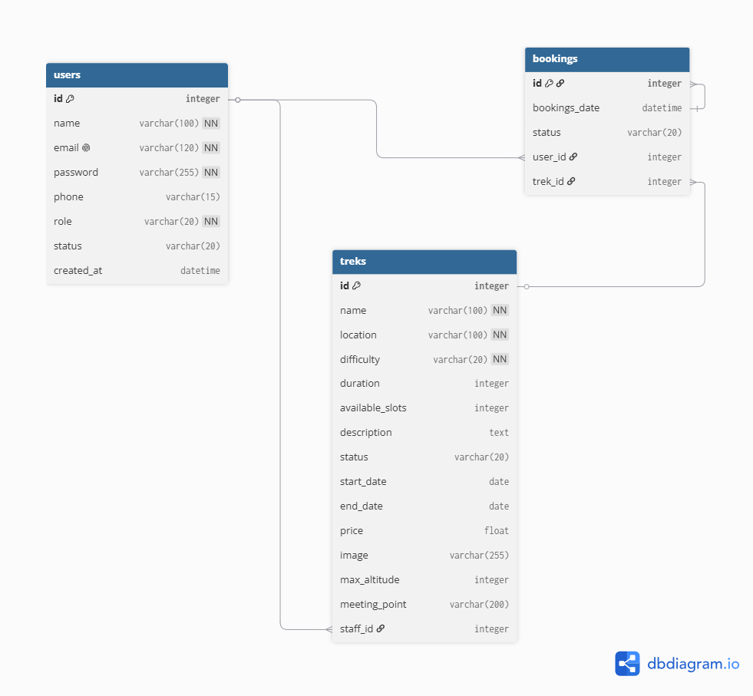

6. API Resource Endpoints
Endpoint | Method | Description
/auth/login | POST | Authenticate user and create a login session
/user/treks | GET | Retrieve all available treks
/user/book/<trek_id> | GET | Book a selected trek
/admin/treks/add | POST | Add a new trek (Admin only)
YAML API Definition File:
Included separately in the submission ZIP as api.yaml.

7. Architecture and Features
Architecture Overview
- app.py – Main Flask application entry point.
- app/models.py – SQLAlchemy database models.
- app/auth, app/admin, app/user, app/staff – Flask Blueprints for role-based modules.
- app/templates – Jinja2 templates for dynamic web pages.
- app/static – CSS, images, and static assets.
Implemented Features
- User registration and secure login.
- Role-based access control (Admin, Staff, User).
- Trek management (Add, Edit, Delete).
- Trek booking and cancellation.
- Staff assignment and participant management.
- Trek search and filtering by location and difficulty.
- User profile and password update.
- Responsive user interface using Bootstrap 5.
Additional Features
- Booking history for users.
- Dashboard for Admin, Staff, and Users with role-specific information.
- Secure password hashing and session management using Flask-Login and Werkzeug Security.

8. Video Presentation
Drive Link: https://drive.google.com/file/d/12RAQiN1cOR5fCOpll9Zo3-IFVUpAEaW5/view?usp=sharing
Github link: https://github.com/MRIGAANKSh/iitm-mad1-project.git

